 | 10.1.4 Editors - Compositor Editor - Header - Select Menu
Table of content
Select menu 1
Legacy 1
Box select 1
Circle select 1
All 2
None 2
Inverse 2
Linked From 2
Linked To 2
Grouped 2
Grouped Extend 2
Activate same type previous 2
Activate same type next 2
Find Node 2

Select menu

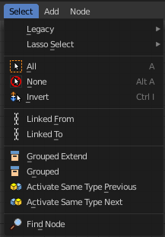
Here you will find the select functionality.

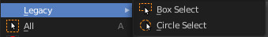
Legacy
The legacy sub menu contains tools that exists in the tool shelf already. It's the old way to do things. Different to the tools in the tool shelf, these tools are usually modal. And performs once. You have to call them again in case you want to repeat the tool.

Box select
Draw a rectangle to select everything inside of the rectangle.
It automatically adds to the current selection. Holding down shift subtracts from the selection.

Circle select
Brush select content. The radius of the brush can be adjusted by holding down left mouse button and using the scroll wheel or the + or - button at the numpad.
It automatically adds to the current selection. Holding down shift subtracts from the selection. To exit the circle select tool click with the right mouse button.

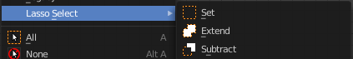
Lasso Select
A sub menu with the available lasso select modes.

All
Select everything.

None
Select nothing.

Inverse
Invert the current selection.

Linked From
Select the nodes that are linked from the currently selected nodes. The nodes before in the hierarchy.

Linked To
Select the nodes that are linked to the currently selected nodes. The nodes behind in the hierarchy.

Grouped
Select grouped nodes.

Grouped Extend
Select grouped nodes, and extend from the current selection.

Activate same type previous
Activate same node type before the current selection, step by step.

Activate same type next
Activate same node type after the current selection, step by step.

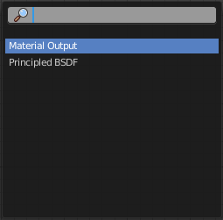
Find Node
This button will open a search dialog where you can search for node types and select them in the current hierarchy.

